# CS 255 System Design Document Template

Thomas Tran

Professor Denise Washington

CS 255 Computer Analysist and Design

April 27th, 2025

This template lays out all the different sections that you need to complete for Project Two. Each section has guidance to prompt your thinking. You will need to continually reference the interview transcript as you work to make sure that you are addressing your client’s needs. There is no required length for the final document. Instead the goal is to complete each section based on what your client’s needs are. Remove this note when you are finished, and replace all bracketed text with the relevant information.

## UML Diagrams

### UML Use Case Diagram

*[In Module Six, you were asked to complete a use case diagram based on your system design. If you would like to make any adjustments to your diagram, please do so. Please insert your use case diagram here. Check to make sure that you included appropriate components and symbols and that your design meets the client’s needs.]*

### UML Activity Diagrams

*[You were asked to choose* ***two*** *use cases and create* ***two*** *activity diagrams, one for each use case. Please insert* ***both*** *of your activity diagrams here. Check to make sure that you included appropriate components and symbols and that your design meets the client’s needs.]*

### UML Sequence Diagram

*[You were asked to create a sequence diagram based on* ***one*** *of the use cases you chose. Please insert your sequence diagram here. Check to make sure that you included appropriate components and symbols and that your design meets the client’s needs.]*

### UML Class Diagram

*[You were asked to create a class diagram based on the different classes and attributes needed for your system design. You are* ***not*** *required to include methods, but you may if you wish. Please insert your class diagram here. Check to make sure that you included appropriate components and symbols and that your design meets the client’s requirements.]*

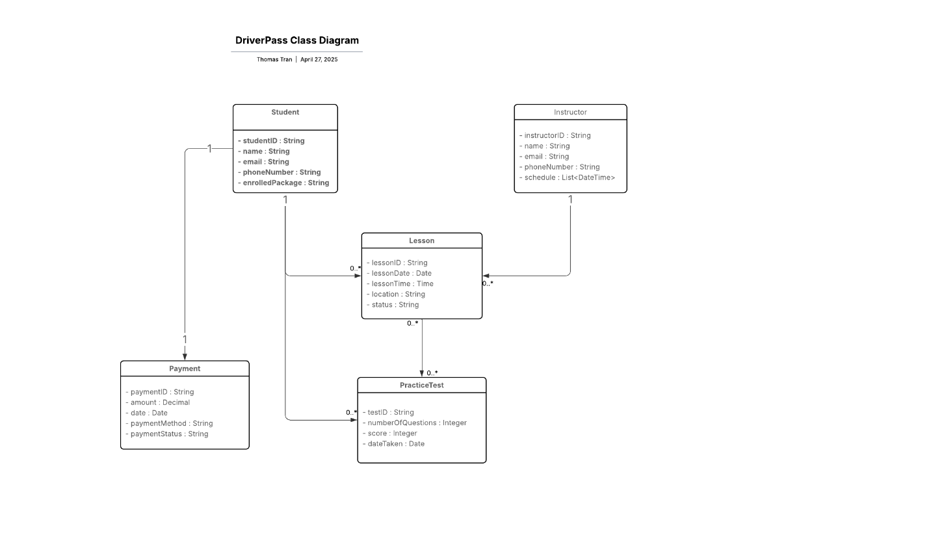

## Technical Requirements

*[Based on the diagrams you have created, describe the technical requirements of your system. These requirements should address the required hardware, software, tools, and infrastructure necessary for your system design.]*

**Hardware Requirements:**

For DriverPass system, a cloud-hosted web server is required to support all its applications and database. For User like student, teacher, IT Admin, they will require hardware capable of Internet access like Computer, Laptop, Smartphones, or Tablet to access DriverPass application.  
The DriverPass server will require a secure network with reliable internet connectivity and strong firewalls will protect server communications and database information.

**Software Requirements:**  
For Software requirement, DriverPass system can run with Linux and/or Windows Server operating systems using their cloud-server application. For Users, the software requirement to access DriverPass is simple modern web browsers, including Chrome, Firefox, Edge, or through smart devices that use Android or MacOS.

**Tools:**  
Development tools like Visual Studio, GitHub, and Lucid Chart can be used in the beginning to develop DriverPass system. Once up and running, DriverPass can be supported even more with tools like cloud hosting services with Amazon AWS, Microsoft Azure, or Google Cloud. Payment processing could be handled with providers like Stripe, PayPal, or Square. Other tools like Data Management, Security Authentication, Security Communication tools will need to be added to DriverPass to ensure satisfaction for all users.

**Infrastructure Requirements:**  
DriverPass can be hosted on a secure cloud platform such as AWS or Azure. Security encryption measures can include SSL/TLS encryption. A multi-factor authentication for user accounts, and regular server backups to protect DriverPass from Hacker attacks and system crashes. A disaster recovery plan with cloud redundancy will protect against data loss or downtime.